2Factor Authentication (2FA) - Enrollment Guide

This document provides a step-by-step guide for users enrolling in 2Factor Authentication (2FA). 2Factor Authentication adds a second layer of security to your BSD account.
Note: If you intend to use the BSD VPN, you will need to enroll in DUO Two-Factor Authentication and register a qualifying device. This is a requirement for the BSD instance of VPN.
Step 1

To enroll in 2FA, visit the 2Factor Authentication website, 2fa.bsd.uchicago.edu, and choose to opt in by selecting the Go to 2Factor button.

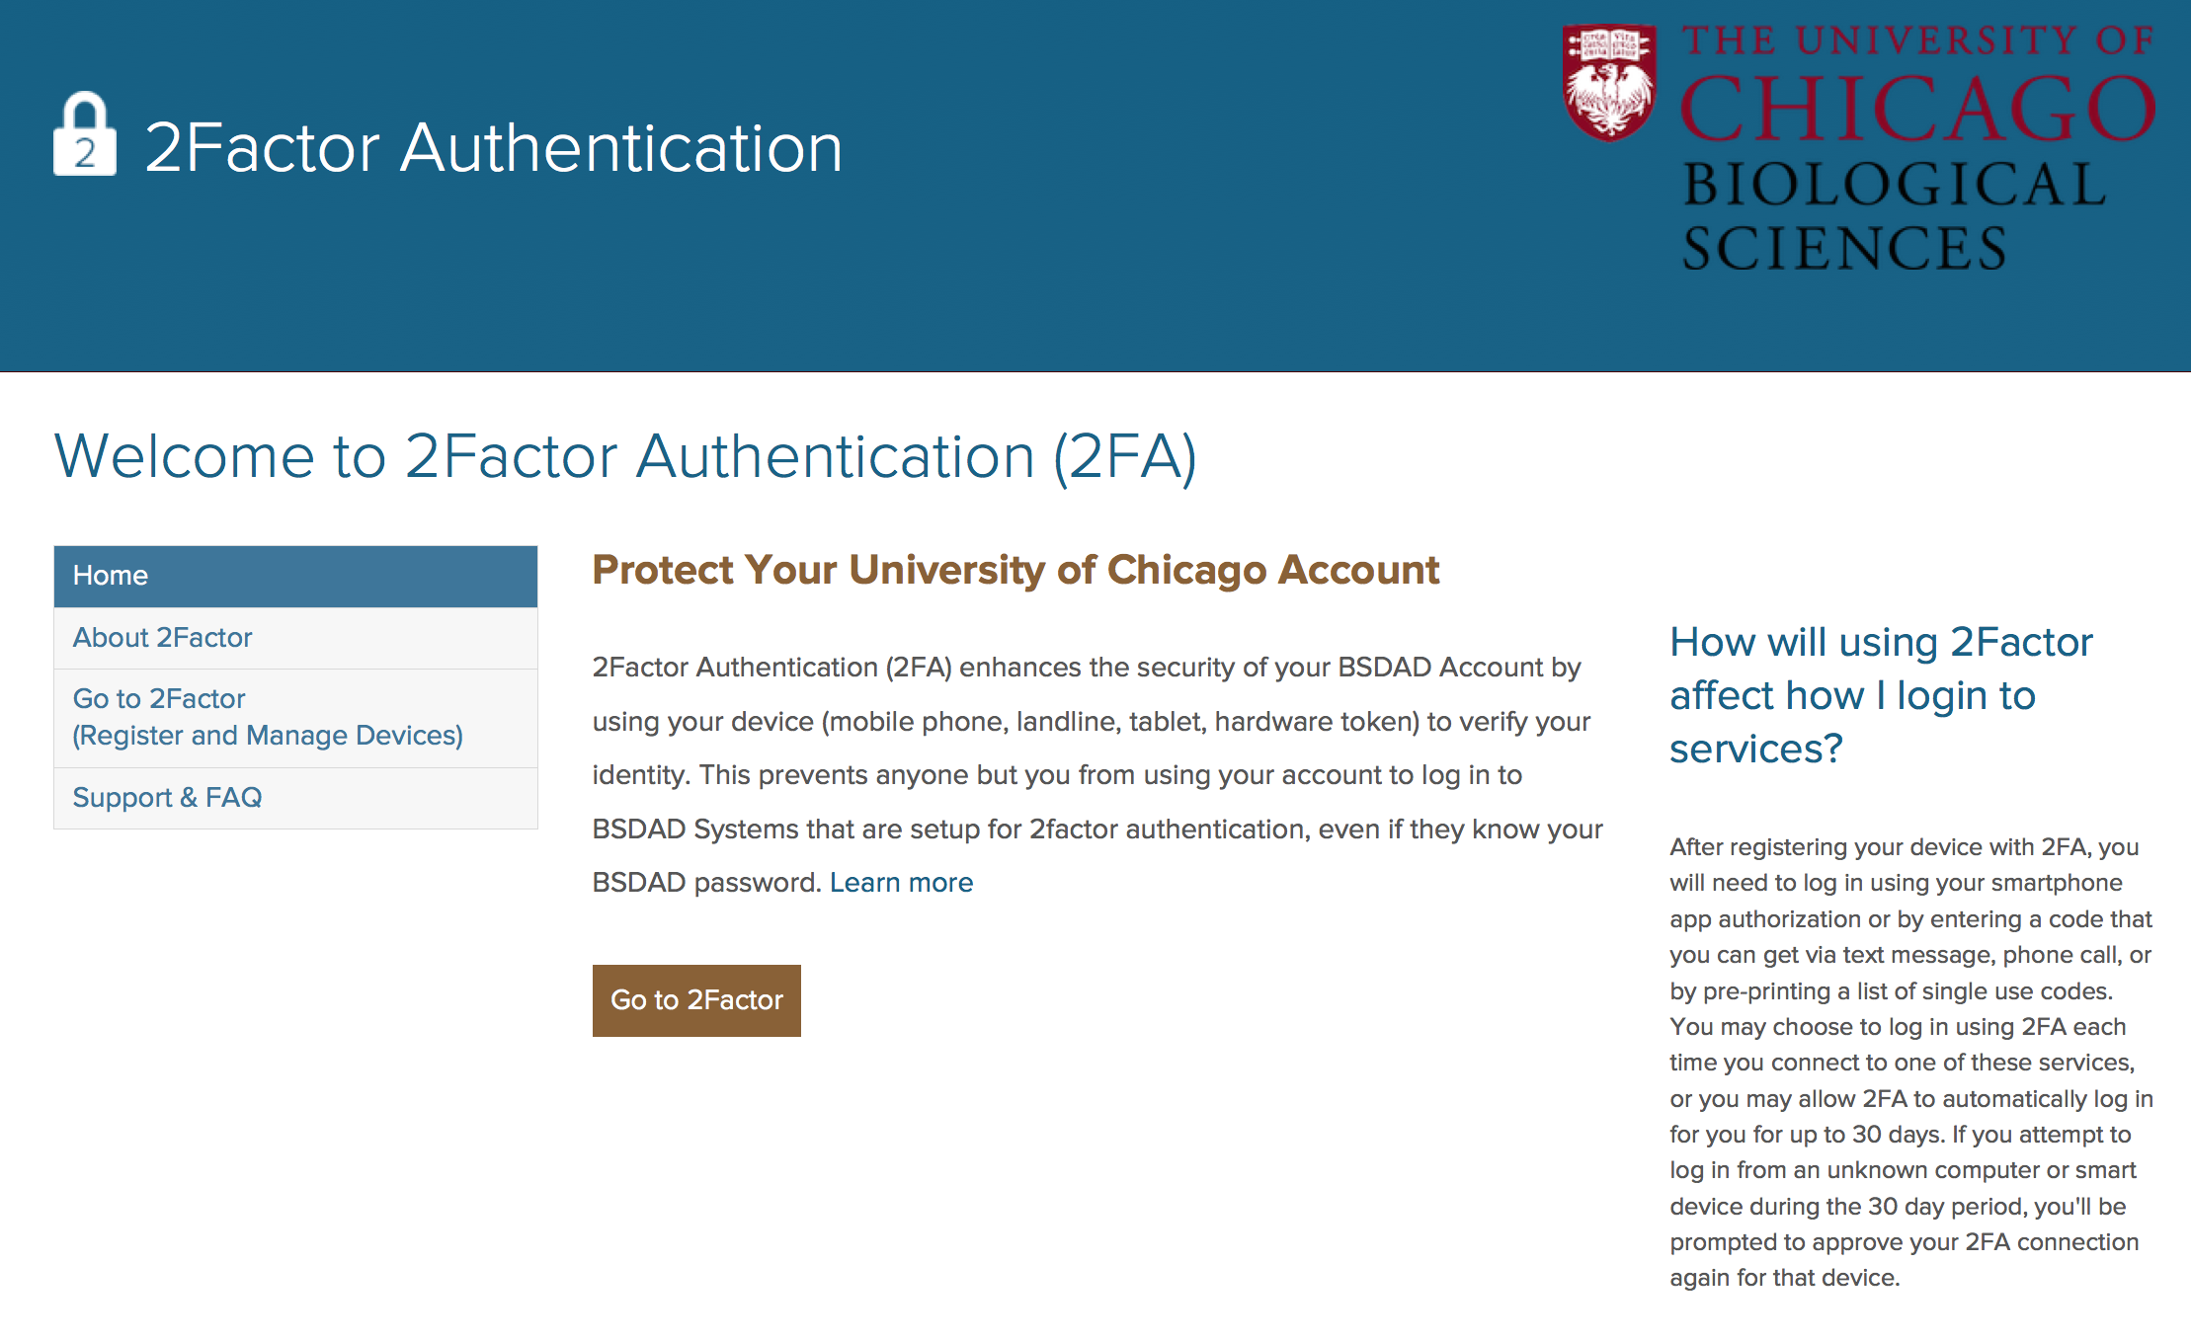

Step 2

The system directs you to log in using your BSDAD username and password.

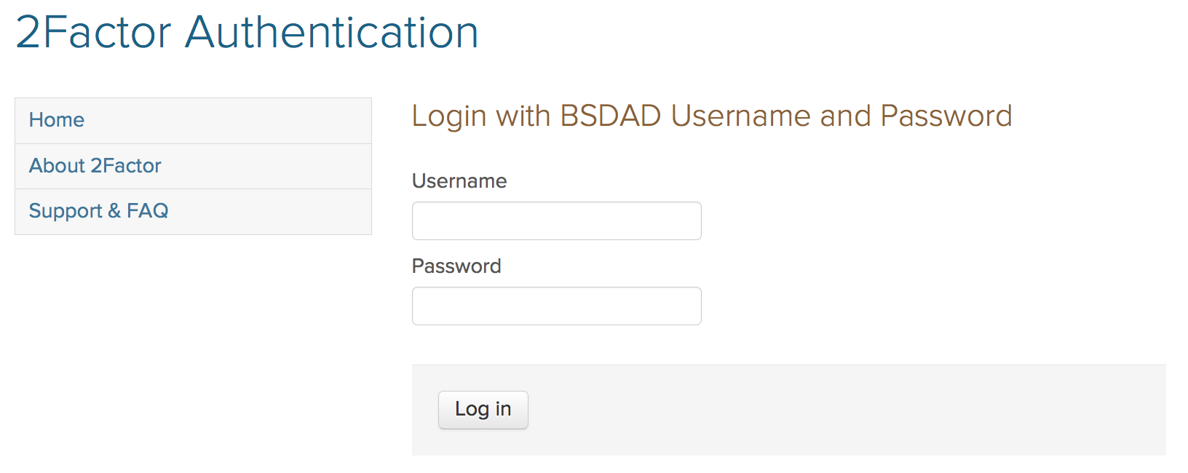

Step 3

If you have not previously enrolled in 2FA, you will be prompted to press the Register a Device button.

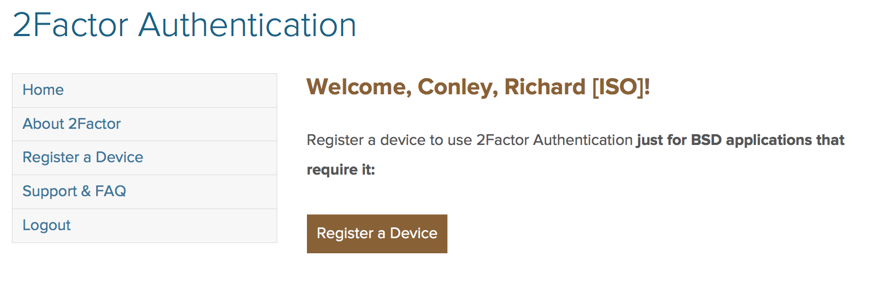

Step 4

Register your smartphone for 2FA by choosing the Mobile Phone device type and then select the blue Continue button towards the bottom of the screen. If you do not have a smartphone, you may choose to register an alternative device, such as a tablet, a landline, or a hardware token.

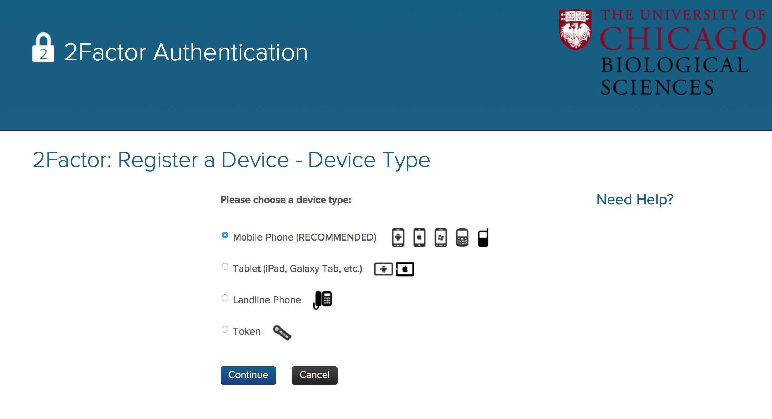

Step 5

On the next screen, enter your mobile phone number for the device you are registering with 2FA. Select Continue when finished.
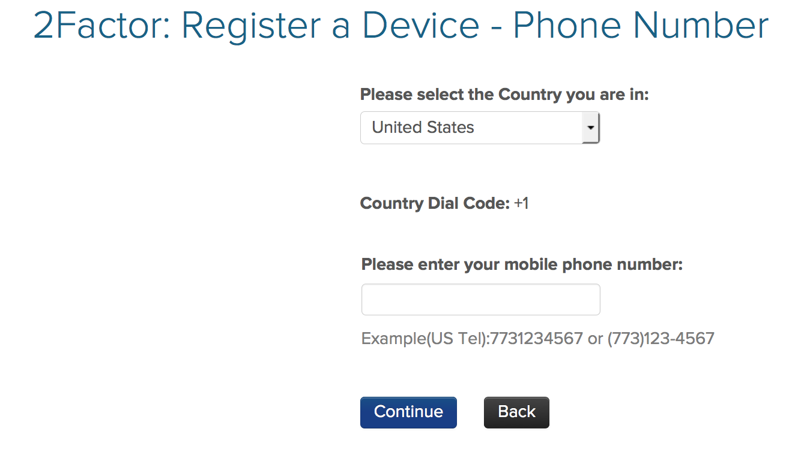

Step 6

Identify the operating system that your smartphone or device uses and select the Continue button.
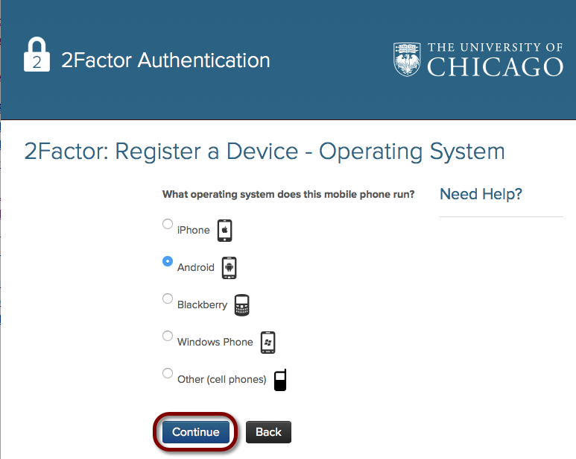
Step 7

After selecting the operating system for your device, you will be prompted to download the Duo Mobile App onto your phone, either through the App Store (iPhone) or Google Play Store (Android). Confirm that you have installed the app on your phone by checking the box on the bottom of this screen and then select Continue.
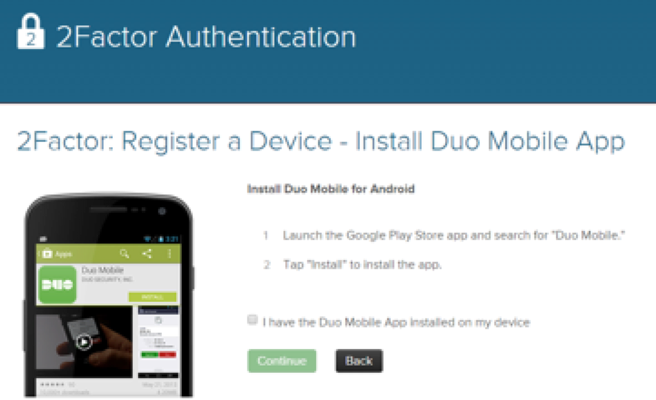

Step 8

The Duo Activation Code appears on the next screen. Open your Duo Mobile app found on your smartphone and scan the Quick Response (QR) code that appears.
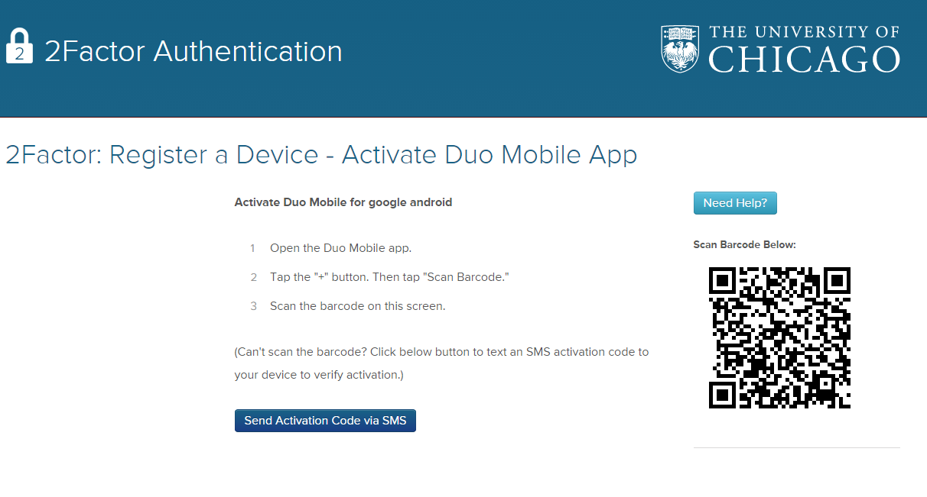
Step 9

To scan the QR, press the + plus button in the upper-right hand corner of the app. Simply hold your phone up and scan the QR code found on your computer screen.
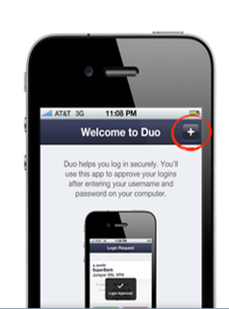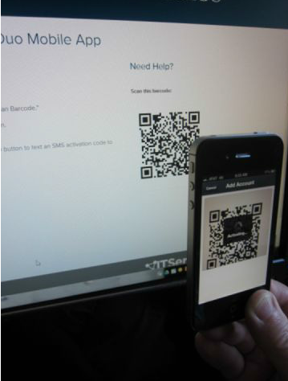

Step 10

When the QR code is scanned correctly, an acknowledgement displays (shown below) that your device has been successfully registered. Immediately enroll another device by pressing the Enroll Another Device button. If you choose not to enroll another device at this time, select the Done button.

Note that having more than one device enrolled in 2FA is strongly encouraged in the event that you lose or forget your device.
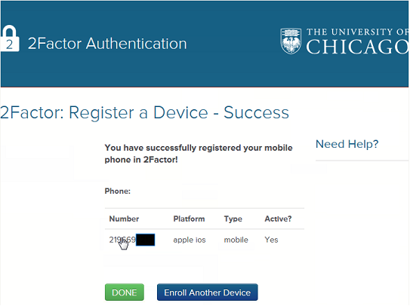

Step 11

From this point forward any service that utilizes 2FA will prompt for this service after you enter your BSDAD username and password into that service (BSD VPN, etc.). With 2FA enabled, the username and password become your first factor.

You are then directed to the DUO login prompt screen. This second factor is independent verification that you are who you say you are through the device you have enrolled or registered with 2FA. Select your device of choice (if you have more than one enrolled) and your preferred method of notification (a phone call, push notification, etc.) See Step 12 (listed below) for an explanation of these notification methods.
The Second Factor: Device Notification
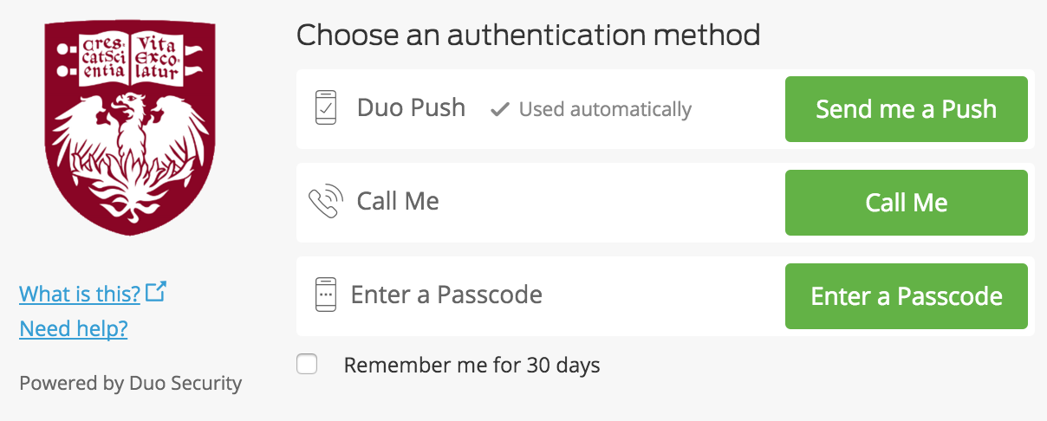
Note: if you check the box found on the bottom of this screen, you will also be given the option for your browser to remember you for 30 days.

Step 12

- If you have a smartphone, Duo Push is a one-tap authentication on your device and is the preferred form of notification for smartphones (see Step 13).

- Selecting Phone call sends a call to your phone; simply answer the call and press any button on your phone to verify you have received the call.

- If you wish to use a Passcode, you may request that a set of 10 unique passcodes be sent via text message to your registered device from the 2FA Manage Devices screen. Please note that you must have your passcode before you attempt to access a site that is protected with 2FA. Passcodes also work within the Duo Prompt screen. Because a passcode that is used once cannot be used again, you must keep track of which passcodes have been used.

METHOD | DESCRIPTION
Duo Push | Pushes a login request to your phone (if you have Duo Mobile installed and activated on your iPhone, Android, or BlackBerry device). Just review the request and tap Approve to log in.
Phone Call | Authenticate via phone callback.
Passcode | Log in using a passcode, either generated with Duo Mobile, sent via SMS, generated by your hardware token, or provided by an administrator.  Click Send SMS passcodes to get a new batch of passcodes.

Step 13

If you have chosen to use Duo Push notification, a log in request is sent to your phone. Select the Approve button on your phone to authenticate. Authenticating through 2FA allows you to have secure access to all usual BSDAD sites and applications.

