Utilizing Keylight Rm – Risk Exceptions

Risk Manager, part of the Keylight platform from LockPath, organizes your enterprise risk management program by centralizing the documentation, scoring, prioritization and remediation of all types of risks. Lets look in to how Risk Exception Requests are processed.

**How to log a Risk Exception**

1. Navigate to <https://itcompliance.bsd.uchicago.edu/>
   1. This website is only available on-campus or by utilizing the VPN
2. Click *Single Sign On*
   1. You will be directed to the University of Chicago Shibboleth/SAML portal.
3. Login using your CNET credentials
   1. If you do not have CNET credentials, a portal account will be created for you upon request.
4. In the upper right corner, mouse over *Rm* and click the *Risk Register* option

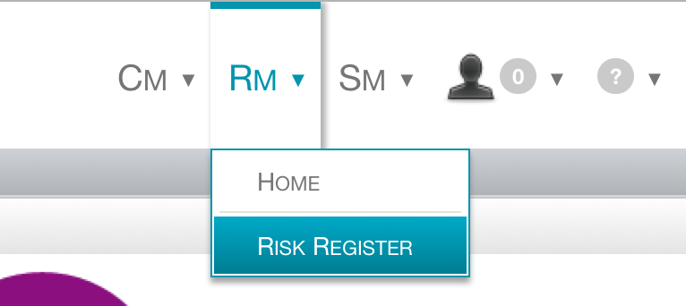

1. Click *Create Risk Exception*
2. Fill out all fields under the *Enterprise Risk* tab
3. Click *Save*
4. Mouse over *Actions* and click *Submit to SA for evaluation*

That’s all! The exception will processed in accordance with the Risk Exception workflow. See Appendix A for the workflow flowchart.

If you have any questions regarding the status of your risk exception request please contact us at [s.cri.security@bsd.uchicago.edu](mailto:s.cri.security@bsd.uchicago.edu).

Macintosh HD:Users:conleyr1:Desktop:December Archive:LockPath Rm - Risk Exception Simplified.pdfAppendix A – Risk Exception Flow