Utilizing Keylight Cm – Managing Compliance Documents

The Keylight Platform is designed to help enterprises manage all facets of compliance and information security programs, including policies and procedures, risk assessment and mitigation, incident tracking and remediation, vulnerability management, third-party risk management, business continuity planning and audit preparation.

**Logging in to LockPath Keylight**

1. Navigate to <https://itcompliance.bsd.uchicago.edu/>
   1. This website is only available on-campus or by utilizing the VPN
2. Click *Single Sign On*
   1. You will be directed to the University of Chicago Shibboleth/SAML portal.
3. Login using your CNET credentials
   1. If you do not have CNET credentials, a portal account will be created for you upon request.

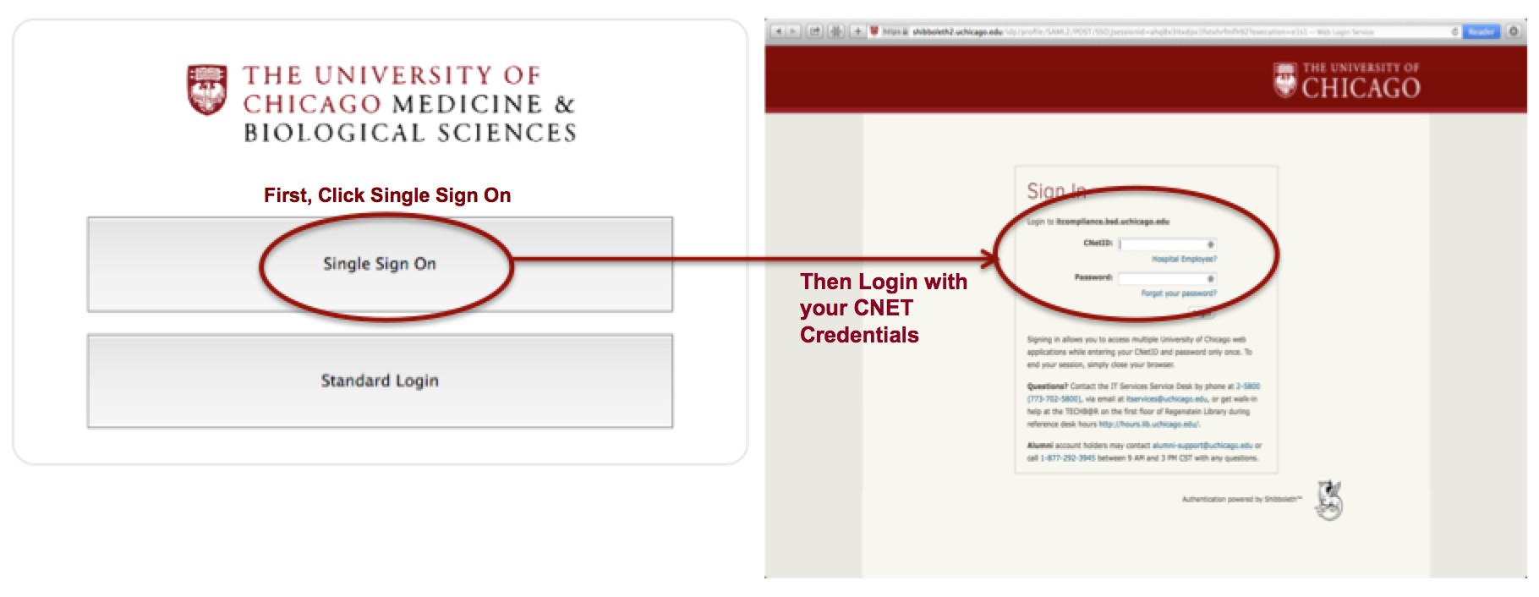

**Acknowledging Compliance Documents**

Many documents will require you to review and acknowledge that you understand the requirements of you and your department.

1. If this is the case you will receive an email requesting you to acknowledge the compliance document.
2. The notification will contain a link to the Keylight system.
3. Click the link and you’ll be forwarded directly to <https://itcompliance.bsd.uchicago.edu/>
   1. This website is only available on-campus or by utilizing the VPN
4. Click *Single Sign On*
   1. You will be directed to the University of Chicago Shibboleth/SAML portal.
5. Login using your CNET credentials
   1. If you do not have CNET credentials, a portal account will be created for you upon request.
6. Review the record, click the check box at the bottom of the record and click *OK*.
   1. You’ll be forwarded to your dashboard.
   2. You can log out at this time..

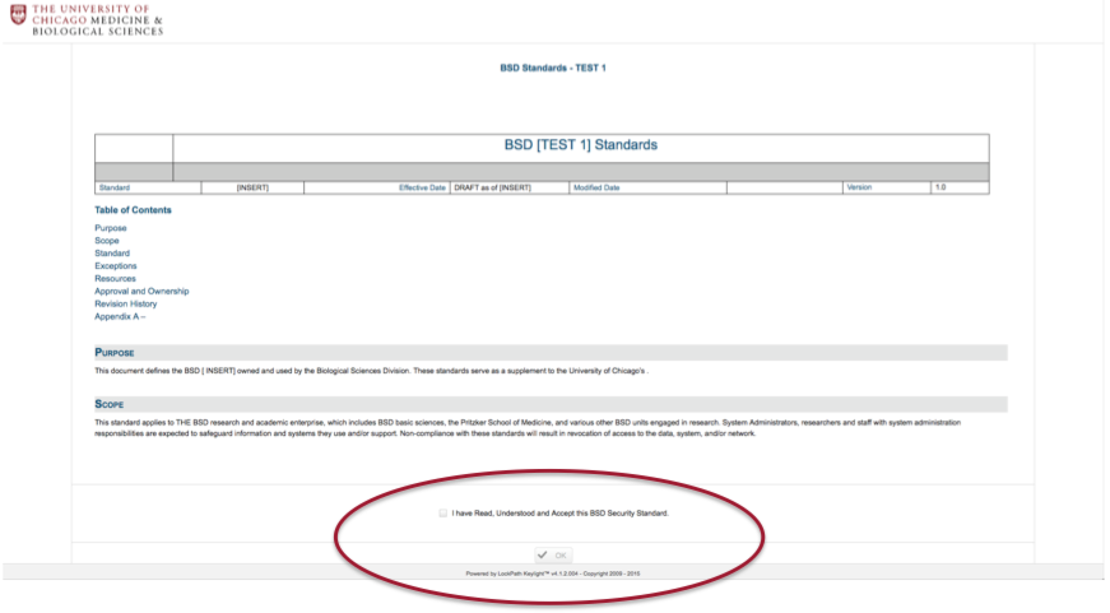

**Managing Compliance Documents**

1. In the upper right corner, mouse over *Cm* and click the *Compliance Documents* option
   1. All active and published compliance documents will be displayed in the column to the left.
2. If you wish to author a new Compliance Document, click “*Create XXXX*” with XXXX representing the type of document you wish to create.
   1. Depending on the document type, there may be a template preloaded for you to edit.
   2. You will be forwarded into a rich text document editor.
   3. If this is the case skip ahead to step 7.
3. If you wish to alter an existing document, select the Compliance Document you wish to edit by clicking on the title of that document from the Active Document list.
   1. Alternatively, you may have received an *Author Assignment Notification* with a deep link.
   2. Clicking that link will forward you directly into the compliance document assigned to you for authoring.

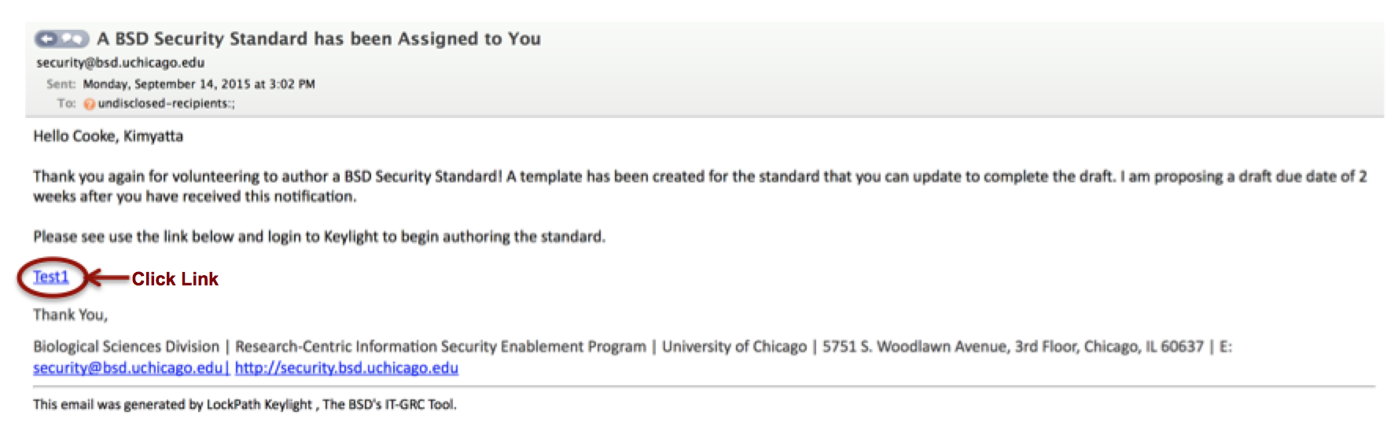

* 1. When you click the link you will be forward into a document management state. In order to edit the document you will need to click edit in the upper right corner of the frame.

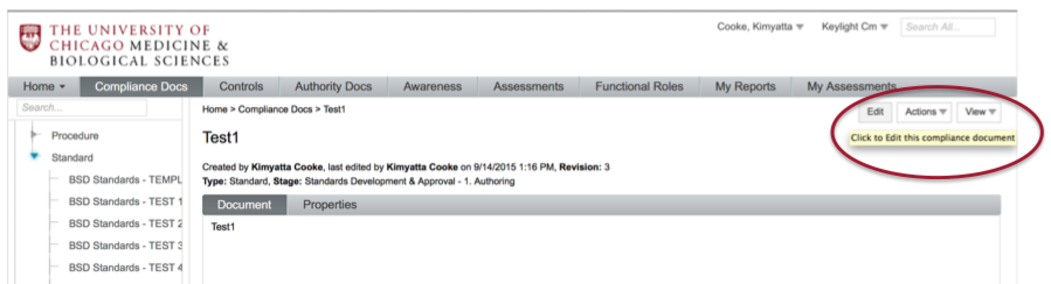

* 1. You will be forwarded into a rich text document editor.

1. Fill out all relevant fields, author or upload the document and click Save.
   1. The BSD ISO recommends working directly in the rich text editor whenever possible as the converted documents from Word documents to rich text editors often have errors that need to be addressed before submitting to maintain formatting and data integrity.

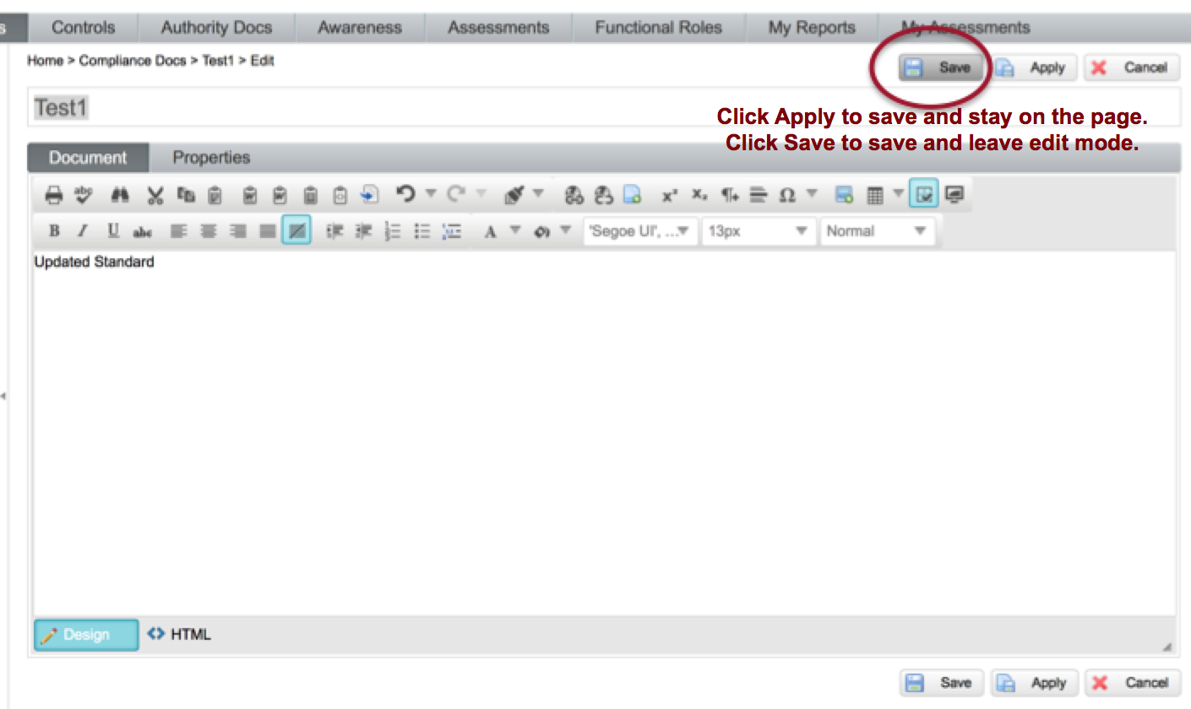

1. When you click the link you will be forward into a document management state.
   1. Click the relevant option in the upper right, under Action to push the document through the workflow.

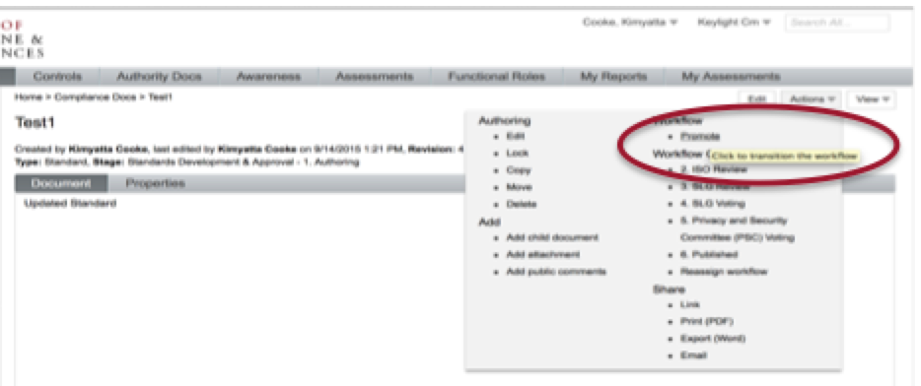

1. Confirm your selection.

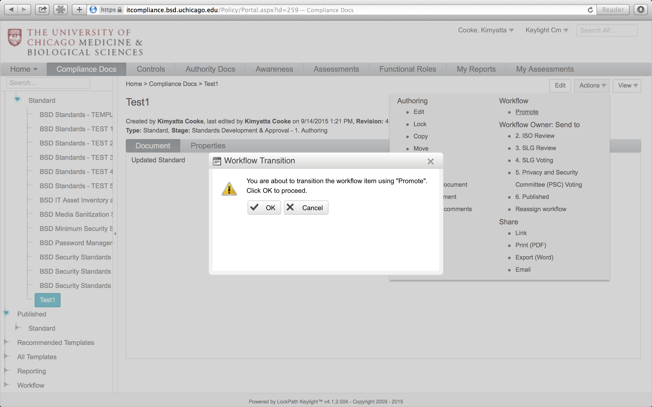

1. The stages will progress from here but this portion of the process is complete.

*If a record is returned to you:*

If there is information missing from a document it may be returned to you as the author.

1. If this is the case, you will like receive a *Additional Information Needed in Draft XXXX Notification*
2. The notification will contain a deep link to the specific record.
3. Click the link and you’ll be forwarded directly to the record in question
   1. You may need to authenticate depending on whether or not you have an active shibboleth/SAML session.
4. When you click the link you will be forward into a document management state.
   1. In order to edit the document you will need to click edit in the upper right corner of the frame.
5. Make the necessary changes and click Save in the upper right.
6. When you click the link you will be forward into a document management state.
   1. Click the relevant option in the upper right, under Action to push the document through the workflow.

*If you are a member of a voting stage:*

Many records and workflows will require a consensus of committees, tasks forces and other groups to process and become published. If you are on a group similar to this and are using the LockPath system to process compliance documents, you may find yourself notified that a document has been pushed into voting phase.

1. If this is the case, you will like receive a *Draft XXXX Ready for Committee Vote Notification*
2. The notification will contain a deep link to the specific record.
3. Click the link and you’ll be forwarded directly to the record in question
   1. You may need to authenticate depending on whether or not you have an active shibboleth/SAML session.
4. When you click the link you will be forward into a document management state.
   1. In voting stages, you will not usually have edit rights.
5. Simply review the document and click Actions in the upper left.
6. Choose the appropriate action (usually some variation of yes/no) and your vote will be recorded.
7. If you need to add comments, feel free to mouse over *Actions* and click *Add public comments*
   1. It is best to add comments prior to voting.
   2. You will also have the ability to add comments when submitting your vote but these are not as visible as those posted in the aforementioned method and thus are not recommended.
8. The votes are tallied by the system and forwarded to the through the workflow accordingly

Appendix A – Guideline Development

Macintosh HD:Users:conleyr1:Documents:Projects (ISO-2015):LockPath Keylight:LockPath Workflows and Flowcharts:LockPath Flowcharts:LockPath Cm - Guidelines Development and Approval Workflow WF Flowchart.pdf